ABOUT US:

|  |  |
| --- | --- |
| ROLE | NAME |
| TEAM LEAD | NAMALA MONIKA |
| SENIOR DEVELOPER | YADLA NAGA YAMUNA YOGITHA KUMARI |
| SENIOR DEVELOPER | KAMICHETTY VEERA RAMYA |
| SENIOR DEVELOPER | PENUJULI SUBRAHMANYAM |
| SENIOR DEVELOPER | BORUSU PAVANI |
| JUNIOR DEVELOPER | LALITHA PRIYANKA MULLU |
| JUNIOR DEVELOPER | G.SAI VARSHITHA |
| JUNIOR DEVELOPER | P. JOTHSNA |
| JUNIOR DEVELOPER | KADARI PAVANI |

---------------------------<>---------------------------

BREIF OVERVIEW OF PROJECT

* Finance Management

A Finance Management project is a web-based application designed to help individuals or businesses manage their financial activities in one centralized location. The primary goal of this project is to provide users with tools to track income, expenses, savings, investments, budgeting, and other financial tasks, all while offering a user-friendly experience. This type of system can range from simple personal finance management to complex business finance solutions.



* Purpose of a Finance Management System

1. **Centralization**: Integrates all financial activities in one place for ease of access and management.
2. **Automation**: Automates repetitive tasks such as bill payments, transaction categorization, and budget tracking.
3. **Analysis**: Provides insights into spending habits, income patterns, and investment growth.
4. **Security**: Ensures that sensitive financial data is secure and only accessible by authorized users.

 

The main objectives of this project

* It’s a global organization
* In our organization, it helps the people to invest money and provides money to the people who wants with interest and it is based on their satisfied criteria like their monthly income(to pay of the interest and actual money).

THIS WEBSITE IS HAVING 3 LOGINS



1. **Admin Login**

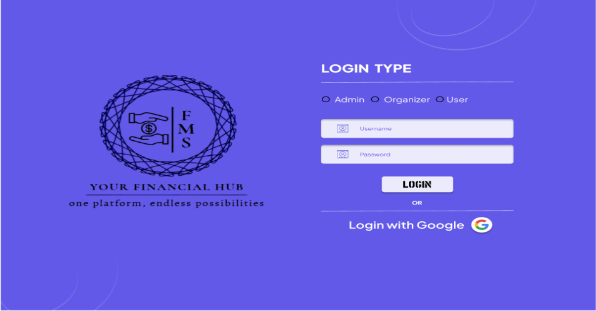



**Purpose:**

* To manage the overall system, including users, organizations, and financial data.

**Responsibilities:**

* **User Management:** Add, remove, and update users and organizations.
* **Access Control:** Manage permissions and roles for different users and organizations.
* **System Configuration:** Configure system settings and parameters.
* **Monitoring and Reporting:** Generate and view system-wide reports and analytics.
* **Data Management:** Oversee data integrity and perform backups.

**Features:**

* Dashboard with an overview of system activity.
* User and organization management interfaces.
* Access logs and system activity monitoring.
* Advanced settings and configuration options.
* FLOWCHART OF ADMIN PAGE

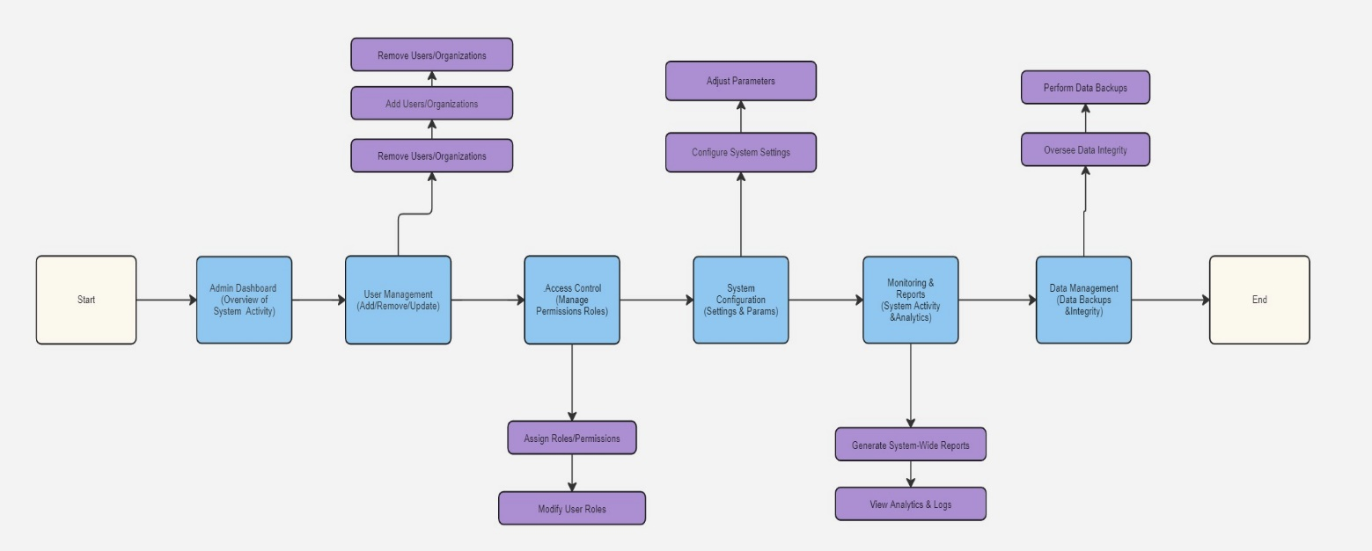

1. **Organization Login**

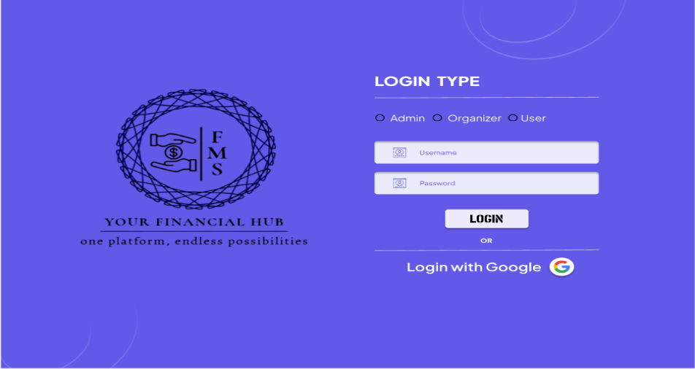



**Purpose:**

* To manage the financial activities and users within a specific organization.

**Responsibilities:**

* **User Management:** Add, remove, and manage users within the organization.
* **Financial Management:** Oversee and manage financial transactions, budgets, and reports for the organization.
* **Reporting:** Generate financial reports and summaries for internal use.
* **Budgeting:** Set and track budgets for different departments or projects within the organization.

**Features:**

* Dashboard with organization-specific financial metrics and activity.
* User management interface for internal users.
* Financial reporting and analytics tools.
* Budget setting and tracking capabilities.

FLOWCHART OF ORGANIZATION PAGE

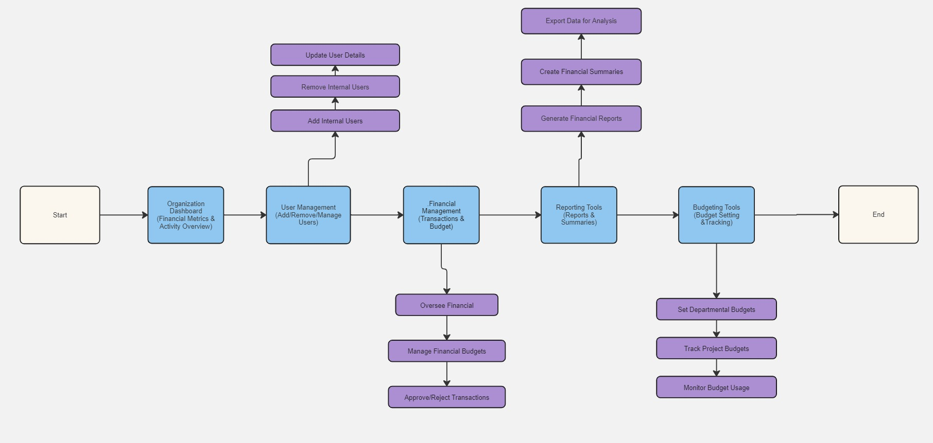

1. **User Login**

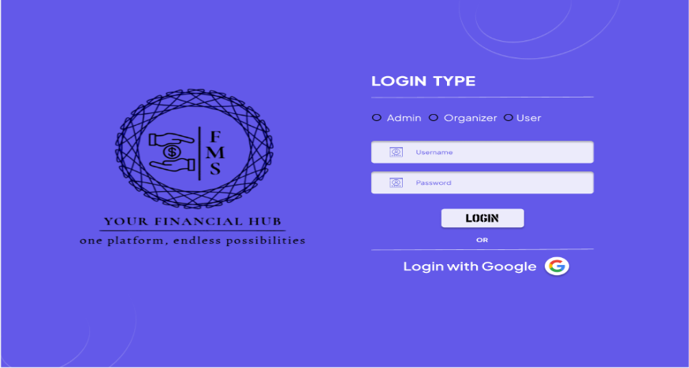



**Purpose:**

* To interact with the finance management system on a personal or departmental level.

**Responsibilities:**

* **Transaction Management:** Perform personal or departmental financial transactions.
* **Expense Tracking:** Track personal or departmental expenses and income.
* **Reporting:** View personal or departmental financial reports and summaries.
* **Budget Tracking:** Monitor adherence to assigned budgets and manage personal or departmental finances.

**Features:**

* Personal or departmental dashboard with financial overview.
* Transaction history and expense tracking.
* Budget adherence and management tools.
* Access to personalized financial reports.

FLOWCHART OF USER PAGE

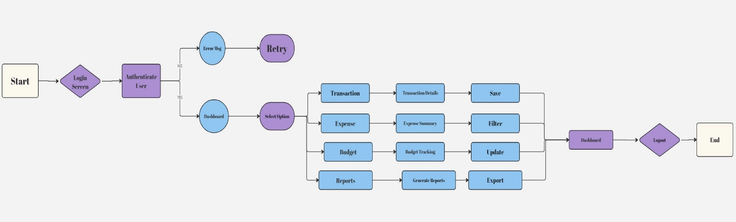

**Integration and Interaction**

* **Admin:** The Admin oversees the entire system and has the highest level of access. They manage the overall operation and ensure that both Organization and User logins function correctly.
* **Organization:** Organizations operate under the Admin’s oversight, managing their internal finances and users while generating reports for their specific needs.
* **User:** Users interact with the system according to their role within an organization, handling personal or departmental financial tasks and reporting.
* Each login type serves a distinct purpose within the system, ensuring efficient management and operation of the finance management project.
* Key Features of a Finance Management System

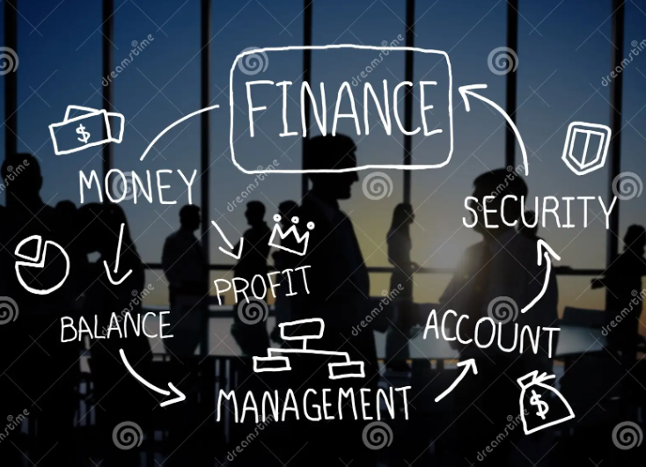

**1. User Authentication & Security**

* **Multi-factor Authentication (MFA)**: Enhance security with MFA options.
* **Role-based Access Control**: Different levels of access depending on user roles (e.g., admin, standard user).
* **Encryption**: Secure storage and transmission of sensitive financial data.

 

**2. Dashboard Overview**

* **Summary of Financial Status**: Display balances for accounts, upcoming bills, recent transactions, etc.
* **Graphs & Charts**: Visual representation of financial data over time.



**3. Budgeting Tools**

* **Custom Budget Creation**: Users can create and customize budgets for various categories like groceries, utilities, entertainment, etc. 
* **Budget Tracking**: Track budget adherence in real-time, alerting users when they are approaching their limits.

**4. Expense & Income Tracking**

* **Categorization**: Automatically categorize expenses and income using machine learning or rule-based systems.
* **Recurring Transactions**: Handle recurring payments like rent, subscriptions, and salaries.

**5. Investment Management**

* **Portfolio Tracking**: Monitor the performance of investments like stocks, bonds, mutual funds, etc.
* **Investment Analysis**: Provide insights into portfolio performance and suggest rebalancing if needed.



**6. Savings Goals**

* **Goal Setting**: Users can set savings goals and track progress.
* **Automated Savings**: Automate transfers to savings accounts based on user-defined rules.



**7. Bill Management**

* **Bill Tracking**: Track upcoming bill payments with reminders.
* **Automated Payments**: Integrate with payment gateways to handle automatic payments.



**8. Reporting & Analytics**

* **Financial Reports**: Generate detailed reports for periods (monthly, quarterly, annually).
* **Spending Analysis**: Analyze spending habits, identify trends, and suggest cost-saving measures.



**9. Tax Management**

* **Tax Calculations**: Automatically calculate taxes based on income, investments, and other financial data.
* **Tax Filing Assistance**: Integrate with tax filing services or generate prefilled tax forms.



**10. Mobile Accessibility**

* **Responsive Design**: Ensure the site works seamlessly on mobile devices.
* **Mobile App**: Offer a companion mobile app for on-the-go access. 

**Unique Features for Enhanced User Experience**

1. **AI-Powered Financial Advice**:
   * Implement AI-driven insights and recommendations based on user behavior, financial goals, and market trends.
2. **Social Spending Analysis**:
   * Compare users' spending patterns with those of peers (anonymously) to offer perspective and motivation.
   * Introduce elements like achievements, badges, and streaks to encourage good financial habits.



1. **Voice Integration**:
   * Integrate with voice assistants (like Alexa, Google Assistant) for hands-free financial management.
2. **Collaborative Financial Management**:
   * Allow multiple users (like couples or business partners) to manage finances collaboratively with shared goals and budgets.

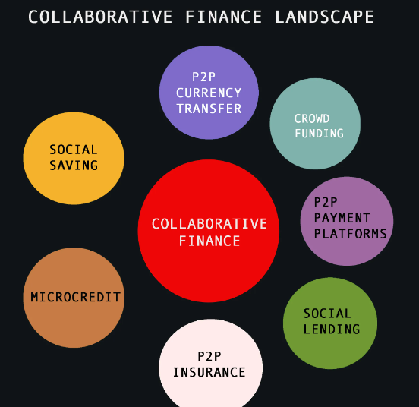 

* **Making It User-Friendly**



* **Intuitive Navigation**: Ensure that the interface is easy to navigate with clear labels and instructions.
* **Customizable Dashboards**: Allow users to customize their dashboard to see the information most relevant to them.
* **Quick Access**: Implement shortcuts for frequently used features like adding a transaction or viewing the budget.
* **Guided Onboarding**: Offer a guided setup for new users to help them get started quickly.
* **Help & Support**: Provide easily accessible help documentation, FAQs, and support channels.

 

* **Unique Aspects to Differentiate from Other Projects**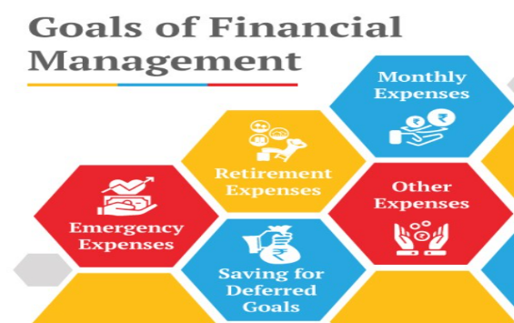
* **Personalization**: Use machine learning to offer personalized financial advice based on user behavior.
* **Sustainability Tracking**: Incorporate a feature that tracks the user's spending on sustainable products and services.
* **Community Integration**: Allow users to join communities or forums to discuss financial strategies and share advice.
* **Open API**: Offer an open API for third-party developers to build plugins or integrations, expanding the system’s functionality.
* **Project Plan: Step-by-Step Guide**

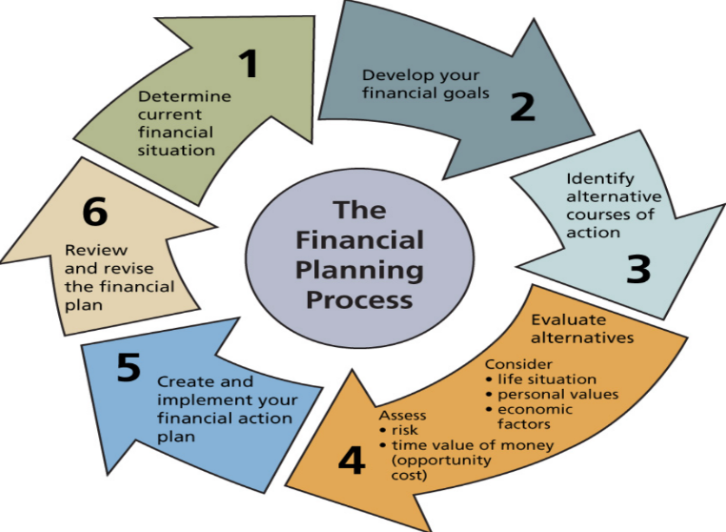

* Phase 1: Planning



1. Requirement Gathering:
   * Define the scope of the project, user needs, and system requirements.
   * Identify target audience (personal users, small businesses, etc.).
2. Technology Stack Selection:



* + **Frontend**: React, Angular, or Vue.js.
  + **Backend**: Node.js with Express, Django, or Flask.
  + **Database**: MongoDB, MySQL, or PostgreSQL.
  + **Security**: Implement SSL, OAuth2, JWT for authentication.

1. Design Prototyping:
   * Use tools like Figma or Adobe XD to create wireframes and prototypes for the application.

**Phase 2: Development**

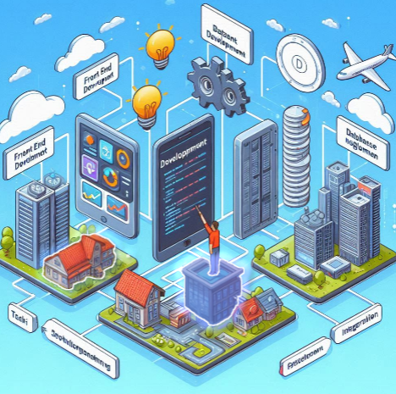

1. Frontend Development:
   * Build the UI components based on the prototypes.
   * Implement responsive design and ensure cross-browser compatibility.
2. Backend Development:
   * Set up server-side logic, API endpoints for data interaction, and database schemas.
   * Implement core features such as user authentication, budget management, and expense tracking.
3. Database Integration:
   * Design database schemas to store user data, transactions, budgets, and other financial information.
   * Optimize queries for performance.
4. API Integration:
   * Integrate with third-party services for payment processing, investment tracking, and tax calculation.

**Phase 3: Testing**



1. Unit Testing:
   * Test individual components and modules for expected functionality.
2. Integration Testing:
   * Ensure that the various parts of the application work together seamlessly.
3. User Acceptance Testing (UAT):
   * Involve potential users to test the application and provide feedback.
4. Security Testing:
   * Conduct penetration testing and vulnerability assessments.

**Phase 4: Deployment**

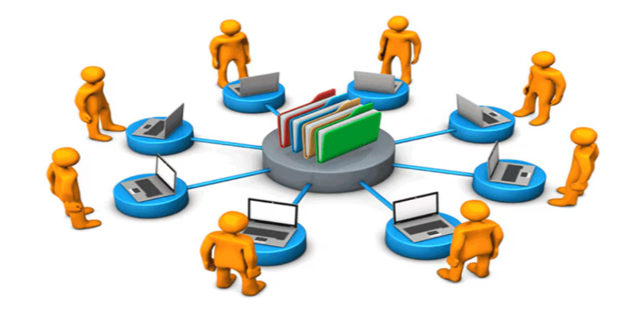

1. Deployment Setup:
   * Set up cloud hosting (e.g., AWS, Azure) and ensure scalability.
2. Continuous Integration/Continuous Deployment (CI/CD):
   * Implement CI/CD pipelines for smooth updates and version control.
3. Launch:
   * Deploy the application to production and make it available to users.

**Phase 5: Post-Launch & Maintenance**

1.User Feedback Collection:

* + Monitor user feedback and application performance.



1. Regular Updates:
   * Roll out updates to add new features, fix bugs, and enhance security.
2. Maintenance:
   * Regularly monitor system performance and address any issues that arise…….

**1. Overall Layout**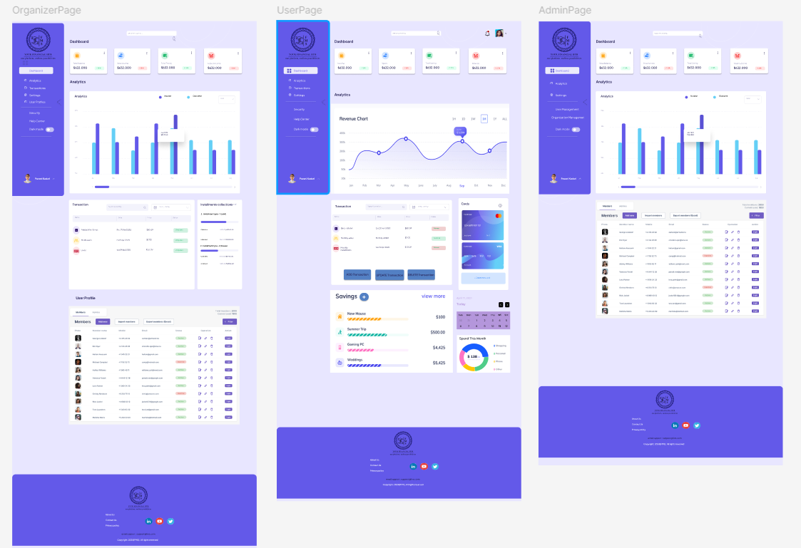

* **Header (Navbar)**: Positioned at the top.
* **Sidebar**: Positioned on the left side.
* **Body (Main Content Area)**: Central area, taking up the most space.
* **Footer**: Positioned at the bottom.

**2. Header (Navbar)**

* **Components to Include:**
  + **Logo**: Positioned on the far left.
  + **Navigation Links**:
    - Home
    - Dashboard
    - Transactions
    - Budgeting
    - Reports
    - Settings
  + **User Profile & Logout**: Positioned on the far right.
  + **Notifications Icon**: Next to the profile.
* **Functionality:**
  + Responsive dropdown menu for smaller screens.
  + Clickable profile for user settings, logout options.

**3. Sidebar**

* **Components to Include:**
  + **Quick Access Links**:
    - Dashboard
    - Add New Transaction
    - Budget Overview
    - Expense Categories
    - Income Tracking
  + **Shortcuts to Key Features**:
    - Financial Goals
    - Investment Portfolio
    - Tax Planning Tools
* **Functionality:**
  + Collapsible sidebar for better usability on smaller screens.
  + Icons for each link for quick identification.

**4. Body (Main Content Area)**

* **Dashboard (Home Page)**:
  + **Overview Cards**: Showing key financial metrics like total balance, expenses, income, and budget status.
  + **Graphs/Charts**: Visual representation of spending habits, income vs. expenses, budget allocation, etc.
  + **Recent Transactions**: List of the most recent transactions with quick access to view or edit them.
* **Transactions Page**:
  + **Table/List**: Detailed view of all transactions with filters (date, category, amount).
  + **Add/Edit Transaction Form**: Popup or inline form to add or edit transactions.
* **Budgeting Page**:
  + **Budget Overview**: Visual representation of the allocated budget vs. actual spending.
  + **Category Management**: Manage different expense categories, set limits, and track spending.
* **Reports Page**:
  + **Financial Reports**: Generate and view monthly, quarterly, and annual financial reports.
  + **Export Options**: Export reports in PDF, Excel, or CSV formats.
* **Settings Page**:
  + **User Preferences**: Change password, set up notifications, manage linked accounts.
  + **App Settings**: Customize the UI, manage data backups, set up multi-currency support.

**5. Footer**

* **Components to Include:**
  + **Quick Links**: Privacy Policy, Terms of Service, Help Center.
  + **Contact Information**: Email, phone number, social media links.
  + **Copyright Information**: “© 2024 App Name. All rights reserved.”

**6. Additional Pages**

* **Login/Signup Page**: Simple, clean UI with options for logging in, signing up, or resetting the password.
* **User Profile Page**: Detailed view of user information, financial goals, and linked accounts.
* **Support/FAQ Page**: List of common issues, how-to guides, and a contact form for additional support.

**Reference links and websites related to financial management project**

* Here are some reference links and websites related to financial management projects that can help you gather information and inspiration for your project:
* **Project Management Institute (PMI) - Financial Management**:
* A comprehensive guide to financial management within project management, including budgeting, cost control, and financial reporting.
* Link to PMI: https://www.pmi.org/
* **GitHub – Open Source Finance Management Projects**:
* Explore various open-source projects related to financial management. These projects can provide you with practical examples and code snippets.
* [Link to GitHub](https://github.com/topics/finance-management)
* **Dribbble - Finance Management UI Designs**:
* A great resource for design inspiration, showcasing user interface designs for financial management systems.
* Link to Dribbble : <https://dribbble.com/>
* **Coursera - Financial Management Courses**:
* Offers online courses that cover financial management concepts and tools that could be useful for your project.
* [Link to Coursera](https://www.coursera.org/courses?query=financial%20management)
* **Investopedia - Financial Management**:
* A resource for learning about financial management principles, including budgeting, financial planning, and investment strategies.
* Link to Investopedia: <https://www.investopedia.com/>
* **Behance - Financial Management App Designs**:
* A platform to view creative designs and UI/UX projects related to financial management applications.
* Conclusion

The Finance Management project is a comprehensive tool designed to streamline all financial activities in one platform. By focusing on user-centric features, strong security, and innovative elements like AI-driven insights and gamification, the system will stand out as a unique and valuable tool for both personal and business finance management.

**THANK YOU**